Progress Notes (Week 5)

GPT produces different responses for each trial. We have to take average score for evaluation.

Trial #1

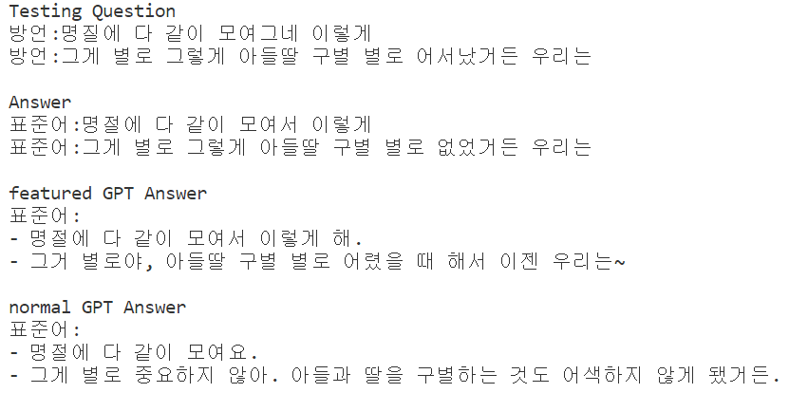

Trial #2

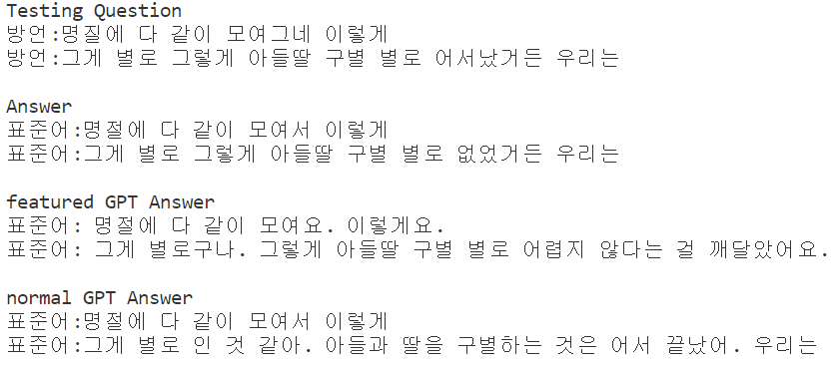

Good Response example

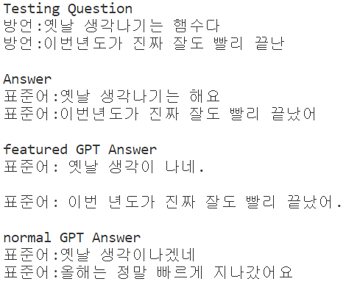

Bad Responses. GPT needs to learn dialect words.

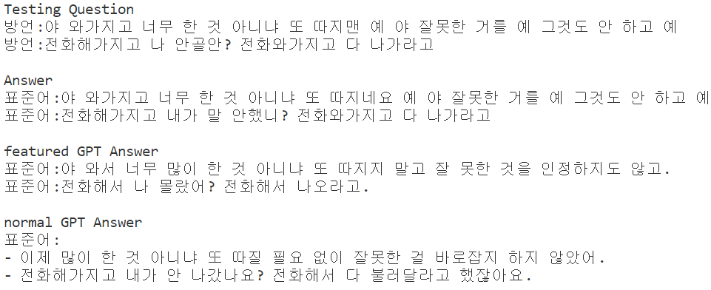

GPT basically works well on easy sentences regardless to any instructions.

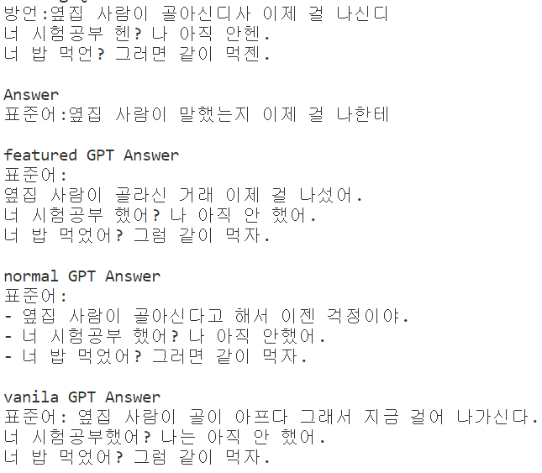

Rebuild dataset with only relevant sentences.

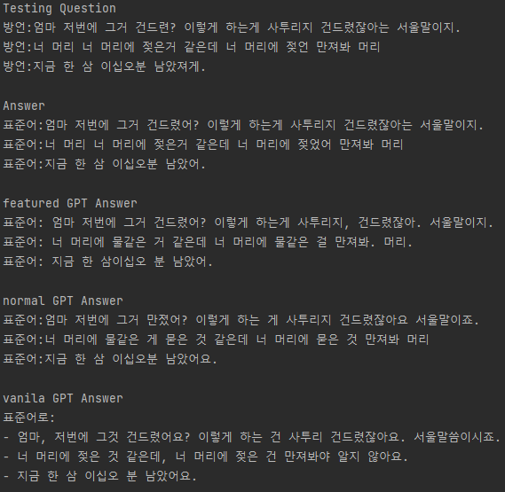

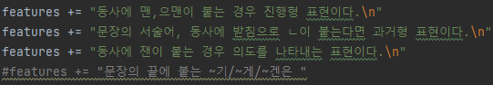

Environment Settings (Hyperparameters)

* The number of training sentences. (Give examples to GPT)
* The number of testing sentences.
* Form of providing Grammar expressions
* Total input tokens.
* Other else..?

GPT에게 주는 Instruction -> 좀 더 좋은 접근 방법이 있을까요?